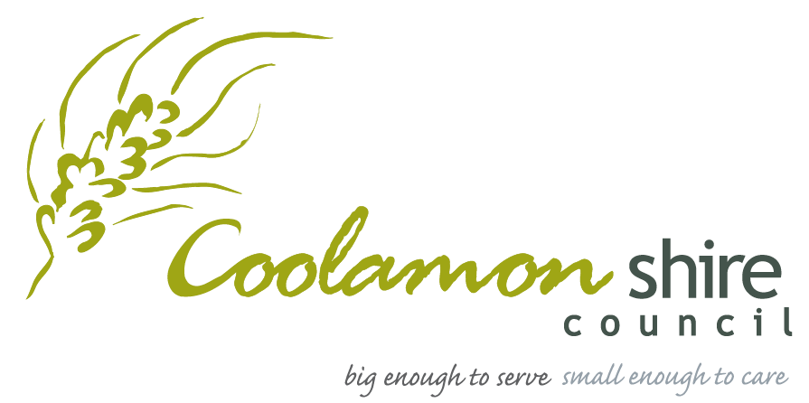

COOLAMON SHIRE
EVENT FUNDING PROGRAM

2024 Guidelines

Amount Available Per Event: Up to $3,000
Funding Pool: $10,000

The event must be held between 1 January 2024 to 31 December 2024.

The application process opens December 2023 and is open until funds are exhausted. Applications can be made anytime during 2024.

Further information please contact:
Laura Munro
Tourism and Business Development Officer
Coolamon Shire Council
02 6927 2492
lmunro@coolamon.nsw.gov.au
Purpose of Program
The Coolamon Shire Event Funding Program provides financial assistance for community or tourism related events held within Coolamon Shire. Funds are to assist Coolamon Shire to increase levels of visitation. This funding is developed and administered by Coolamon Shire Council.

Timeframe and Amount Available
Applicants can apply for funds from a pool of $10,000 (maximum of $3,000 per application, no minimum requirement), which will be assessed and allocated as per the program guidelines. Only one application per applicant per funding round will be considered. If approved, events will only be eligible to apply for funding over two (2) consecutive years. The event must be held between 1 January 2024 to 31 December 2024. Applications will be accepted until the pool of money is exhausted. Once all funds are allocated, applications will not be accepted.

Eligible for Funding
The applicant must be a community based not-for-profit organisation or individual. The event must seek to benefit residents, businesses and/or community groups within the Coolamon Shire.

Funding is eligible for all events, including first year events, providing your event meets the following criteria:

- Your event is held within the Coolamon Shire

- Your organisation must supply one of the following:
  - Certificate of Incorporation;
  - A letter of support from an incorporated organisation willing to sponsor the event; or
  - Other documentation verifying the organisation (eg: bank statements, insurance documents)

- Your organisation must complete the ‘Event Funding Application Form’ and supply all compulsory documentation.
  - A copy of the organisation’s most recent annual report and/or financial statements
  - A copy of the organisation’s Certificate of Currency for Public Liability Insurance
  - A completed Event Budget, highlighting the funding expenditure
  - A completed Risk Assessment and COVID-19 safe plan
  - First year event application must provide documentation and/or business plan highlighting future event sustainability.
(Payment will be made by Coolamon Shire Council after your event has been held and your acquittal documentation has been processed)

- Funding must be used for:
  - Promotion and marketing – Items and activities to assist with the promotion and marketing of the event (Eg: graphic design, printing, photography, TV/radio/social media advertising) or
  - Item or activity that will increase attendees to the event
(Priority will be given to events that will be utilising funding for promotion and marketing)

Not Eligible for Funding
- Organisations that are currently subsidised by Council through existing service level agreements
- Any organisation that has not acquitted any prior grant from Council
- Projects requesting retrospective funding for monies that have already been spent
- Funding towards any unlawful or irresponsible purpose
- Applications that have not enclosed all required documentation (see section ‘Submission Process’)
- Funds that will be distributed to other persons in the form of a donation or gift
- Works that are the responsibility of another government body and/or are eligible to be funded by other government programs
Application Process
Funding opens December 2023 and is open until funds are exhausted. Applications can be made anytime during 2024. Application forms must be completed. Application forms are available for download from www.coolamon.nsw.gov.au. Hard copies or electronic copies are available by phoning 02 6927 2492 or email lmunro@coolamon.nsw.gov.au.

Please ensure your application includes all compulsory support material. You may attach other information that will be of use when assessing your application (Max 5 pages)

Applications can be submitted by:

POST  Coolamon Shire Council  Event Funding Program  PO Box 101  COOLAMON NSW 2701 | EMAIL  council@coolamon.nsw.gov.au  OR  lmunro@coolamon.nsw.gov.au | HAND DELIVERED  (Marked “Coolamon Shire Event Funding Program”)  Coolamon Shire Council  55 Cowabbie Street, COOLAMON NSW 2701

Assessment Criteria
Applications must:
- Complete application and all compulsory documents
- Funds are to be used for marketing, promotion or main item/activity to increase attendees
- Promotion of the event with the purpose of growing an event
- Increasing the number of visitors or the length of stay of visitors
- Evidence of attempted or actual collaboration with other events and industry operators
- How the event aligns with the Community Strategic Plan (www.coolamon.nsw.gov.au)
- If you have received funding for an event for two (2) consecutive years you will need to provide information on how visitor numbers have grown during that period

Assessment and Selection
Applications will be assessed in accordance with the above guidelines and criteria. Applications are assessed by Council Staff with recommendations provided to the next available full Council Meeting for endorsement. Applications are encouraged to be submitted three months prior to the event to allow enough time for approval. Coolamon Shire Council will notify applicants of their outcomes by email.

Successful Events
If your event has been successful in receiving funding, please note:
- Opportunity to discuss event priorities including; marketing, promotion, risk management, finance and approvals with Coolamon Shire Council Staff member and support in the lead up to the event
- Successful event will be promoted within Councils seasonal event marketing campaigns
- Successful applicants are requested to recognise Coolamon Shire Council as a sponsor of the event
- Successful applicants will be accountable to Coolamon Shire Council for the administration of funds
- If a successful applicant needs to change the project to what was originally submitted, contact must be made to Coolamon Shire Council outlining the changes required. If contact is not made within a timely manner Council may revoke the grant offer
- All marketing material and collateral with Coolamon Shire Council’s logo must be approved by Coolamon Shire Council prior to production
- Successful applicants will be required to gather visitation data from the event

Acquittal and How to Receive your Payment
Recipients must acquit funds providing a final report to Council. Your acquittal needs to include:
- Report highlighting event details
- Invoice to Council for total amount awarded
- Copies of receipts/invoices - To demonstrate the expenditure of funds granted
- Photos, flyers, media releases

Your acquittal is to be submitted within two months of completion of event. If acquittals have not been received by two months, Council reserve the right not to consider applications submitted by that applicant in subsequent rounds. Please make contact if you won’t be able to submit within two months.

In order for Council to pay funds, the applicant will need to submit an invoice or tax invoice to Council.
Please note an invoice/tax invoice must be in the name of the supplier. It will be your responsibility to manage the grant funds and make payment to any suppliers that may be used.

Terms and Conditions
- Information provided as part of this application must be true and correct to the best knowledge of the nominated representative. It is an offence to provide false or misleading information.
- All awarded funds must be expended as per the approved application. A variation in the project must be reported to Coolamon Shire Council by email for approval.
- Unused funds must be reported to Coolamon Shire Council and returned. Please discuss with Coolamon Shire Council before returning funds.
- Successful applicants are required to provide an acquittal report.
- Coolamon Shire Council must be acknowledged as supporting the event verbally and within promotional material. Use of Council’s logo requires approval before material is printed.

